RTS Assignment 01

**PART A**

**Question 1: Rate Monotonic Scheduling (RMS) Analysis**

**Calculate the CPU utilization for each task and determine if the set is schedulable using RMS.**

Given task set:

* **T1**: Period = 4 ms, Execution time = 1 ms >> **Utilization UT1** = **0.25**
* **T2**: Period = 5 ms, Execution time = 2 ms >> **Utilization UT2** = **0.4**
* **T3**: Period = 10 ms, Execution time = 3 ms >> **Utilization UT3** = **0.3**

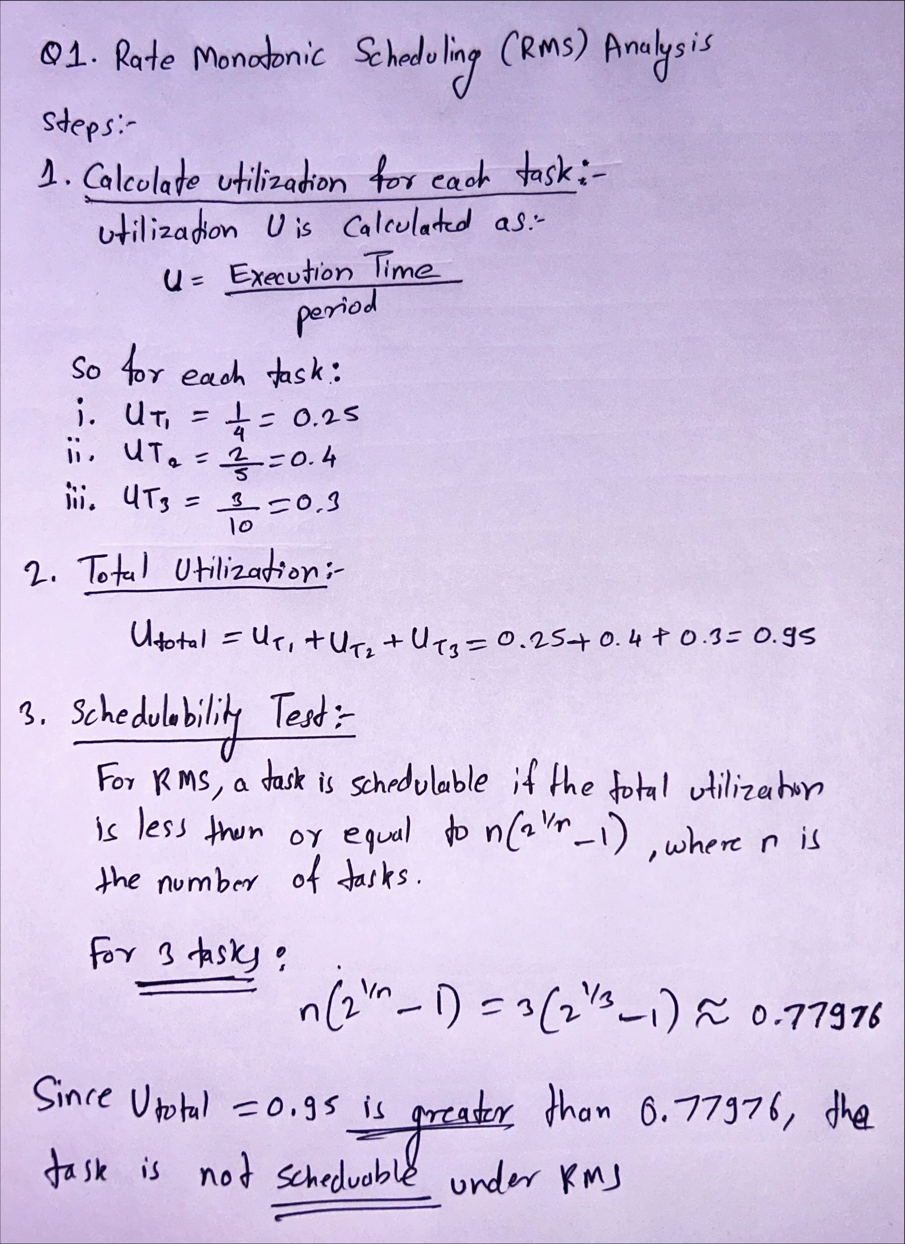

**Question 2: Earliest Deadline First (EDF) Scheduling**

**Calculate the response time for each task and determine if they are schedulable under EDF.**

**Task Set Description:**

In this task set, we are given three periodic tasks, each with its own period, execution time, and deadline:

| **Task** | **Period (ms)** | **Execution Time (ms)** | **Deadline (ms)** |
| --- | --- | --- | --- |
| T1 | 4 | 1 | 4 |
| T2 | 5 | 2 | 5 |
| T3 | 6 | 1 | 6 |

**Cheddar real-time scheduling simulator** to schedule the task set using EDF.

The task parameters (period, execution time, and deadlines) were input into the simulator, and the processor was configured to use the **Earliest Deadline First (EDF)** scheduling policy. The simulation was run over a hyperperiod of 60 ms (the least common multiple of the task periods).

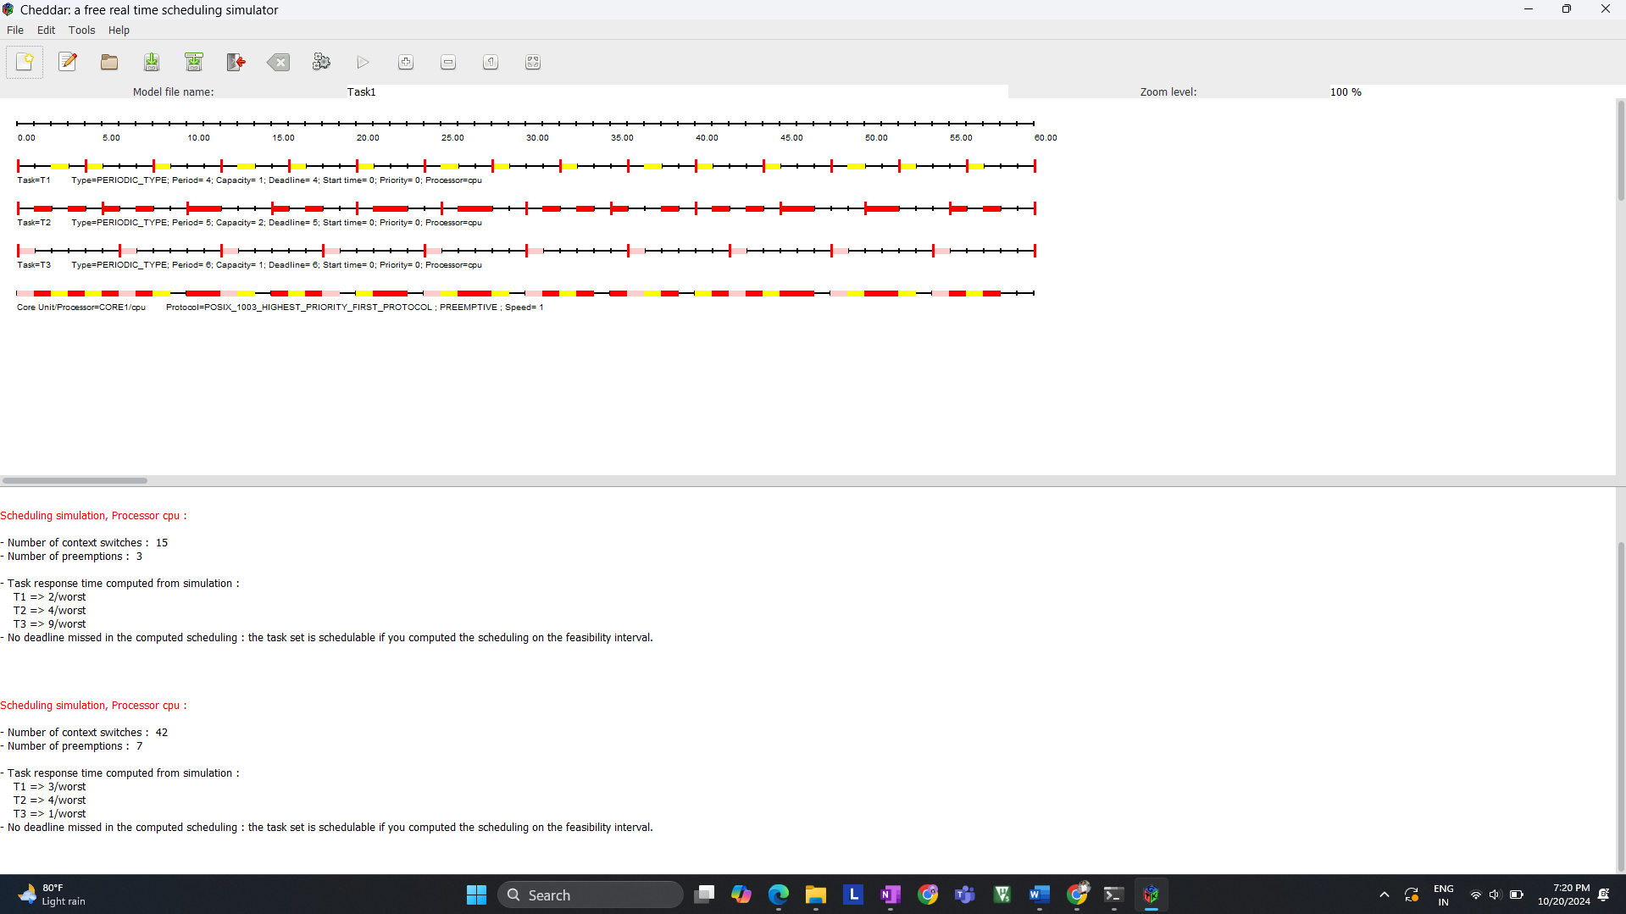

**Gantt Chart:**

Below is the Gantt chart generated by the Cheddar simulator for the EDF scheduling:

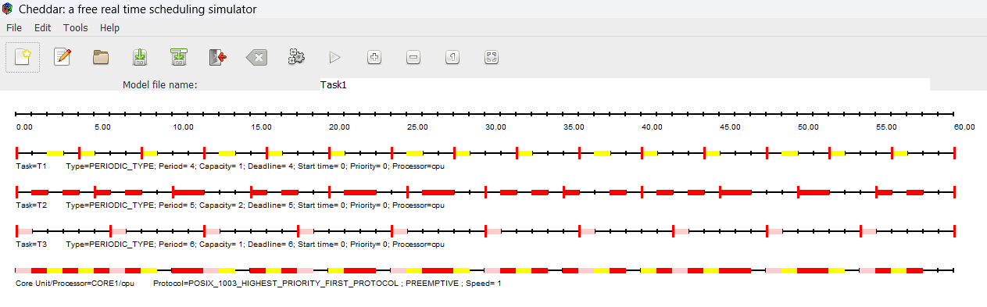

The Gantt chart shows how the tasks are scheduled over time based on their deadlines:

* **Task T1**: Since it has the shortest period (4 ms), it is scheduled frequently and completes its execution before its 4 ms deadline.
* **Task T2**: T2 is scheduled less frequently than T1 but still completes its execution before its 5 ms deadline.
* **Task T3**: T3 has the longest period (6 ms) but is scheduled in between T1 and T2 as per its deadline.

**Response Time and Schedulability:**

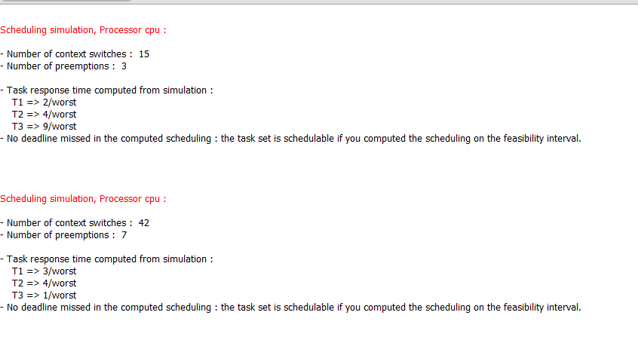

The simulator calculated the worst-case response times for each task. The response time is defined as the time from the task’s release to the time when it completes its execution. The worst-case response times observed are as follows:

| **Task** | **Worst-Case Response Time (ms)** |
| --- | --- |
| T1 | 3 |
| T2 | 4 |
| T3 | 9 (in one run) / 1 (in another run) |

* **T1**: The worst-case response time for T1 is 3 ms, which is less than its deadline of 4 ms, meaning T1 meets its deadline.
* **T2**: T2’s worst-case response time is 4 ms, less than its deadline of 5 ms, so it also meets its deadline.
* **T3**: T3's response time varies between 9 ms and 1 ms, depending on the scheduling scenario, but it still meets its deadline of 6 ms in both cases.

**No deadlines were missed** in the computed scheduling, confirming that the task set is schedulable under EDF.

The task set was successfully scheduled under EDF without missing any deadlines, as confirmed by the Gantt chart and the response time analysis. Despite the dynamic nature of EDF, which results in context switches and preemptions, the scheduling algorithm was able to meet all task deadlines, proving that the task set is **schedulable under EDF**.

**Question 3** Calculate the worst-case response time for each task using a priority scheduling algorithm.

**Given Task Set:**

| **Task** | **Priority (Higher number = Lower priority)** | **Period (ms)** | **Execution Time (ms)** | **Response Time (ms)** |
| --- | --- | --- | --- | --- |
| T1 | 1 (Highest Priority) | 6 | 2 | 2 |
| T2 | 2 | 8 | 3 | 5 |
| T3 | 3 (Lowest Priority) | 10 | 1 | 6 |

We need to calculate the worst-case response time for each task, considering the given priorities. The higher the priority number, the lower the task priority.

We will use the **response-time analysis (RTA)** method, which accounts for the interference from higher-priority tasks. The worst-case response time (Ri) for a task iii is calculated iteratively using:

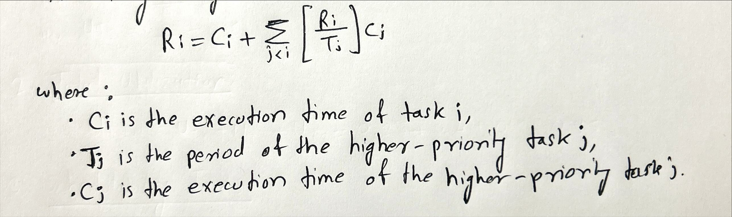

**Step 1: Calculate Response Time for Task T1 (Highest Priority)**

* **T1** has the highest priority (priority = 1), so it is not delayed by any other tasks.
* Therefore, the **response time for T1** is simply its execution time:

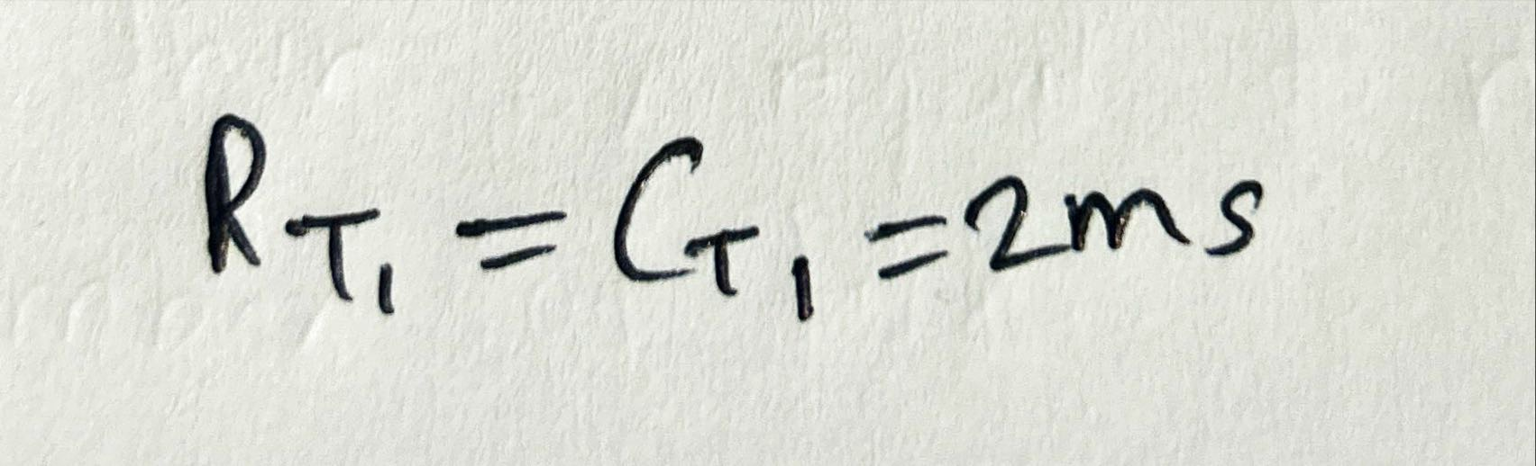

**Step 2: Calculate Response Time for Task T2**

* **T2** has lower priority than **T1**, so it can be delayed by **T1**.
* We calculate the worst-case response time for **T2** using the iterative formula.

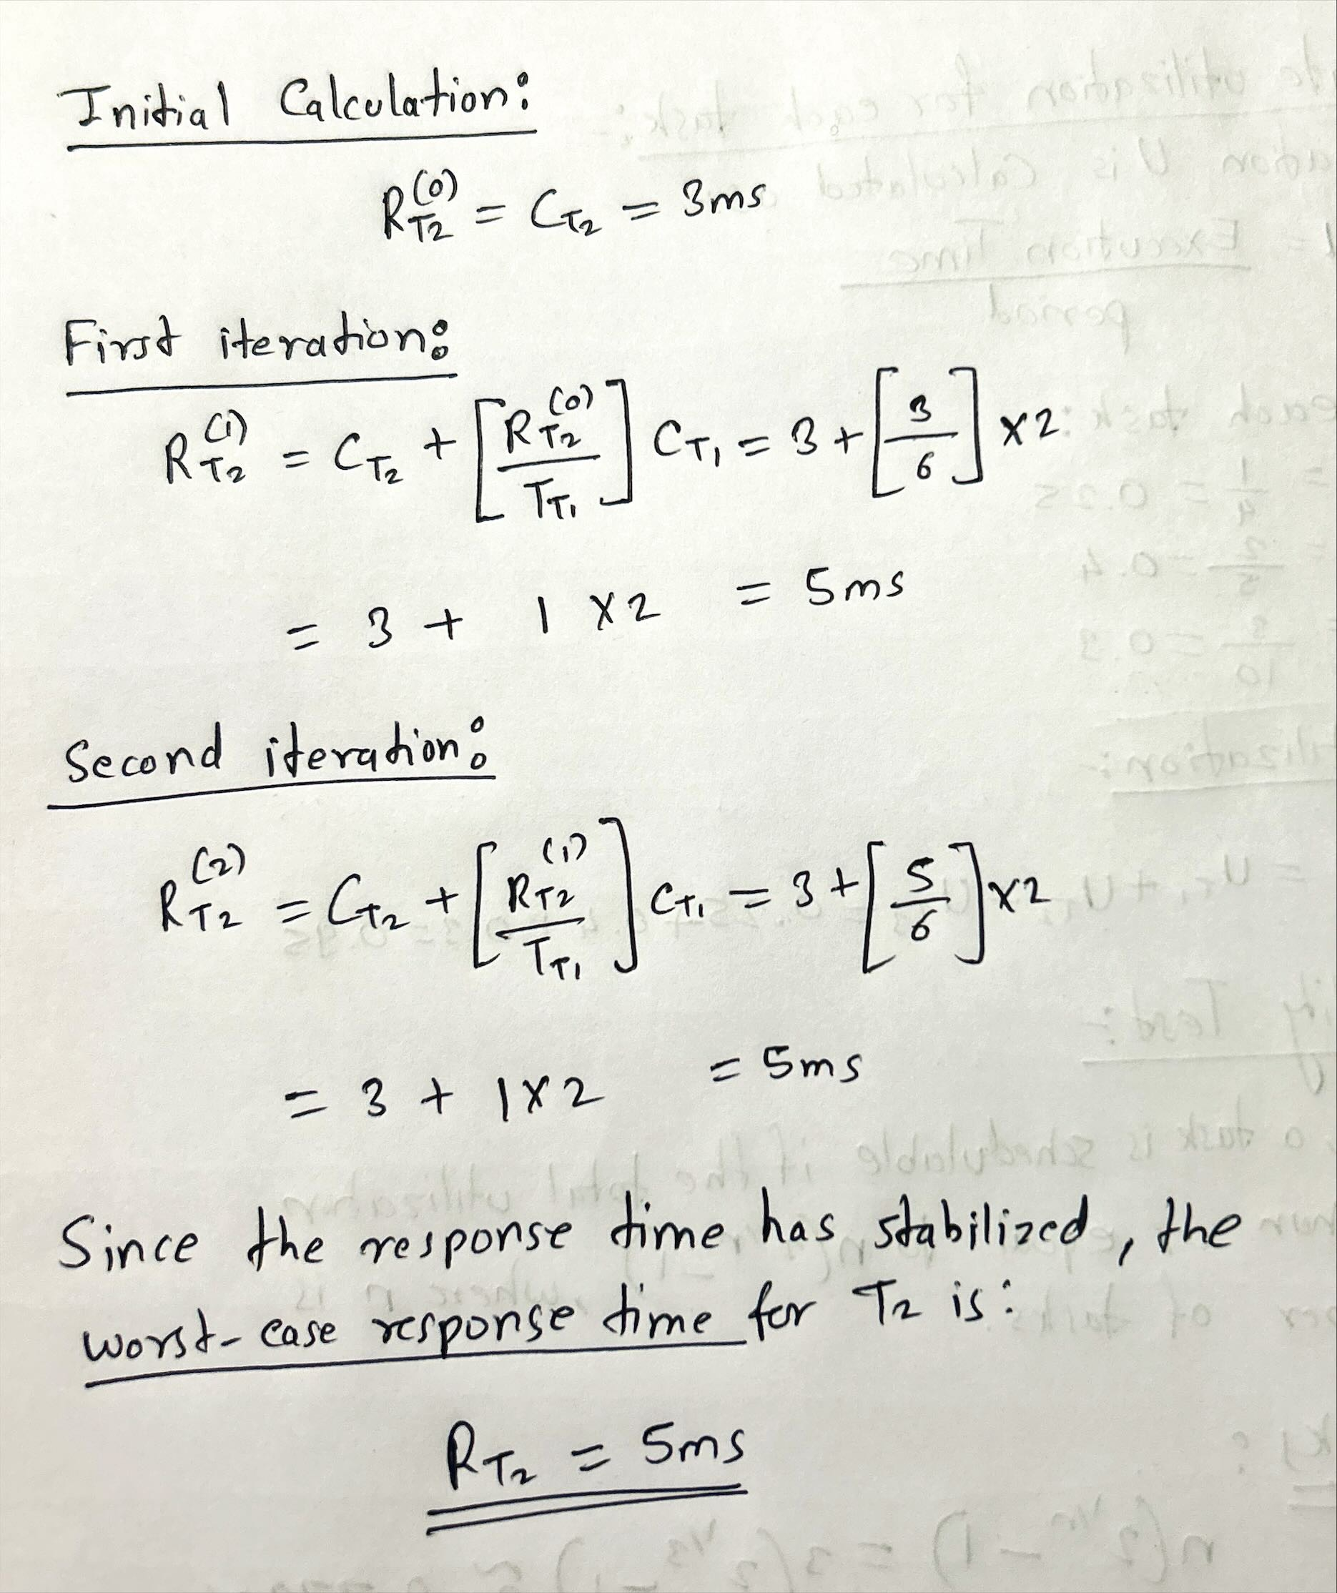

**Step 3: Calculate Response Time for Task T3**

* **T3** has the lowest priority, so it can be delayed by both **T1** and **T2**.
* We calculate the worst-case response time for **T3**.

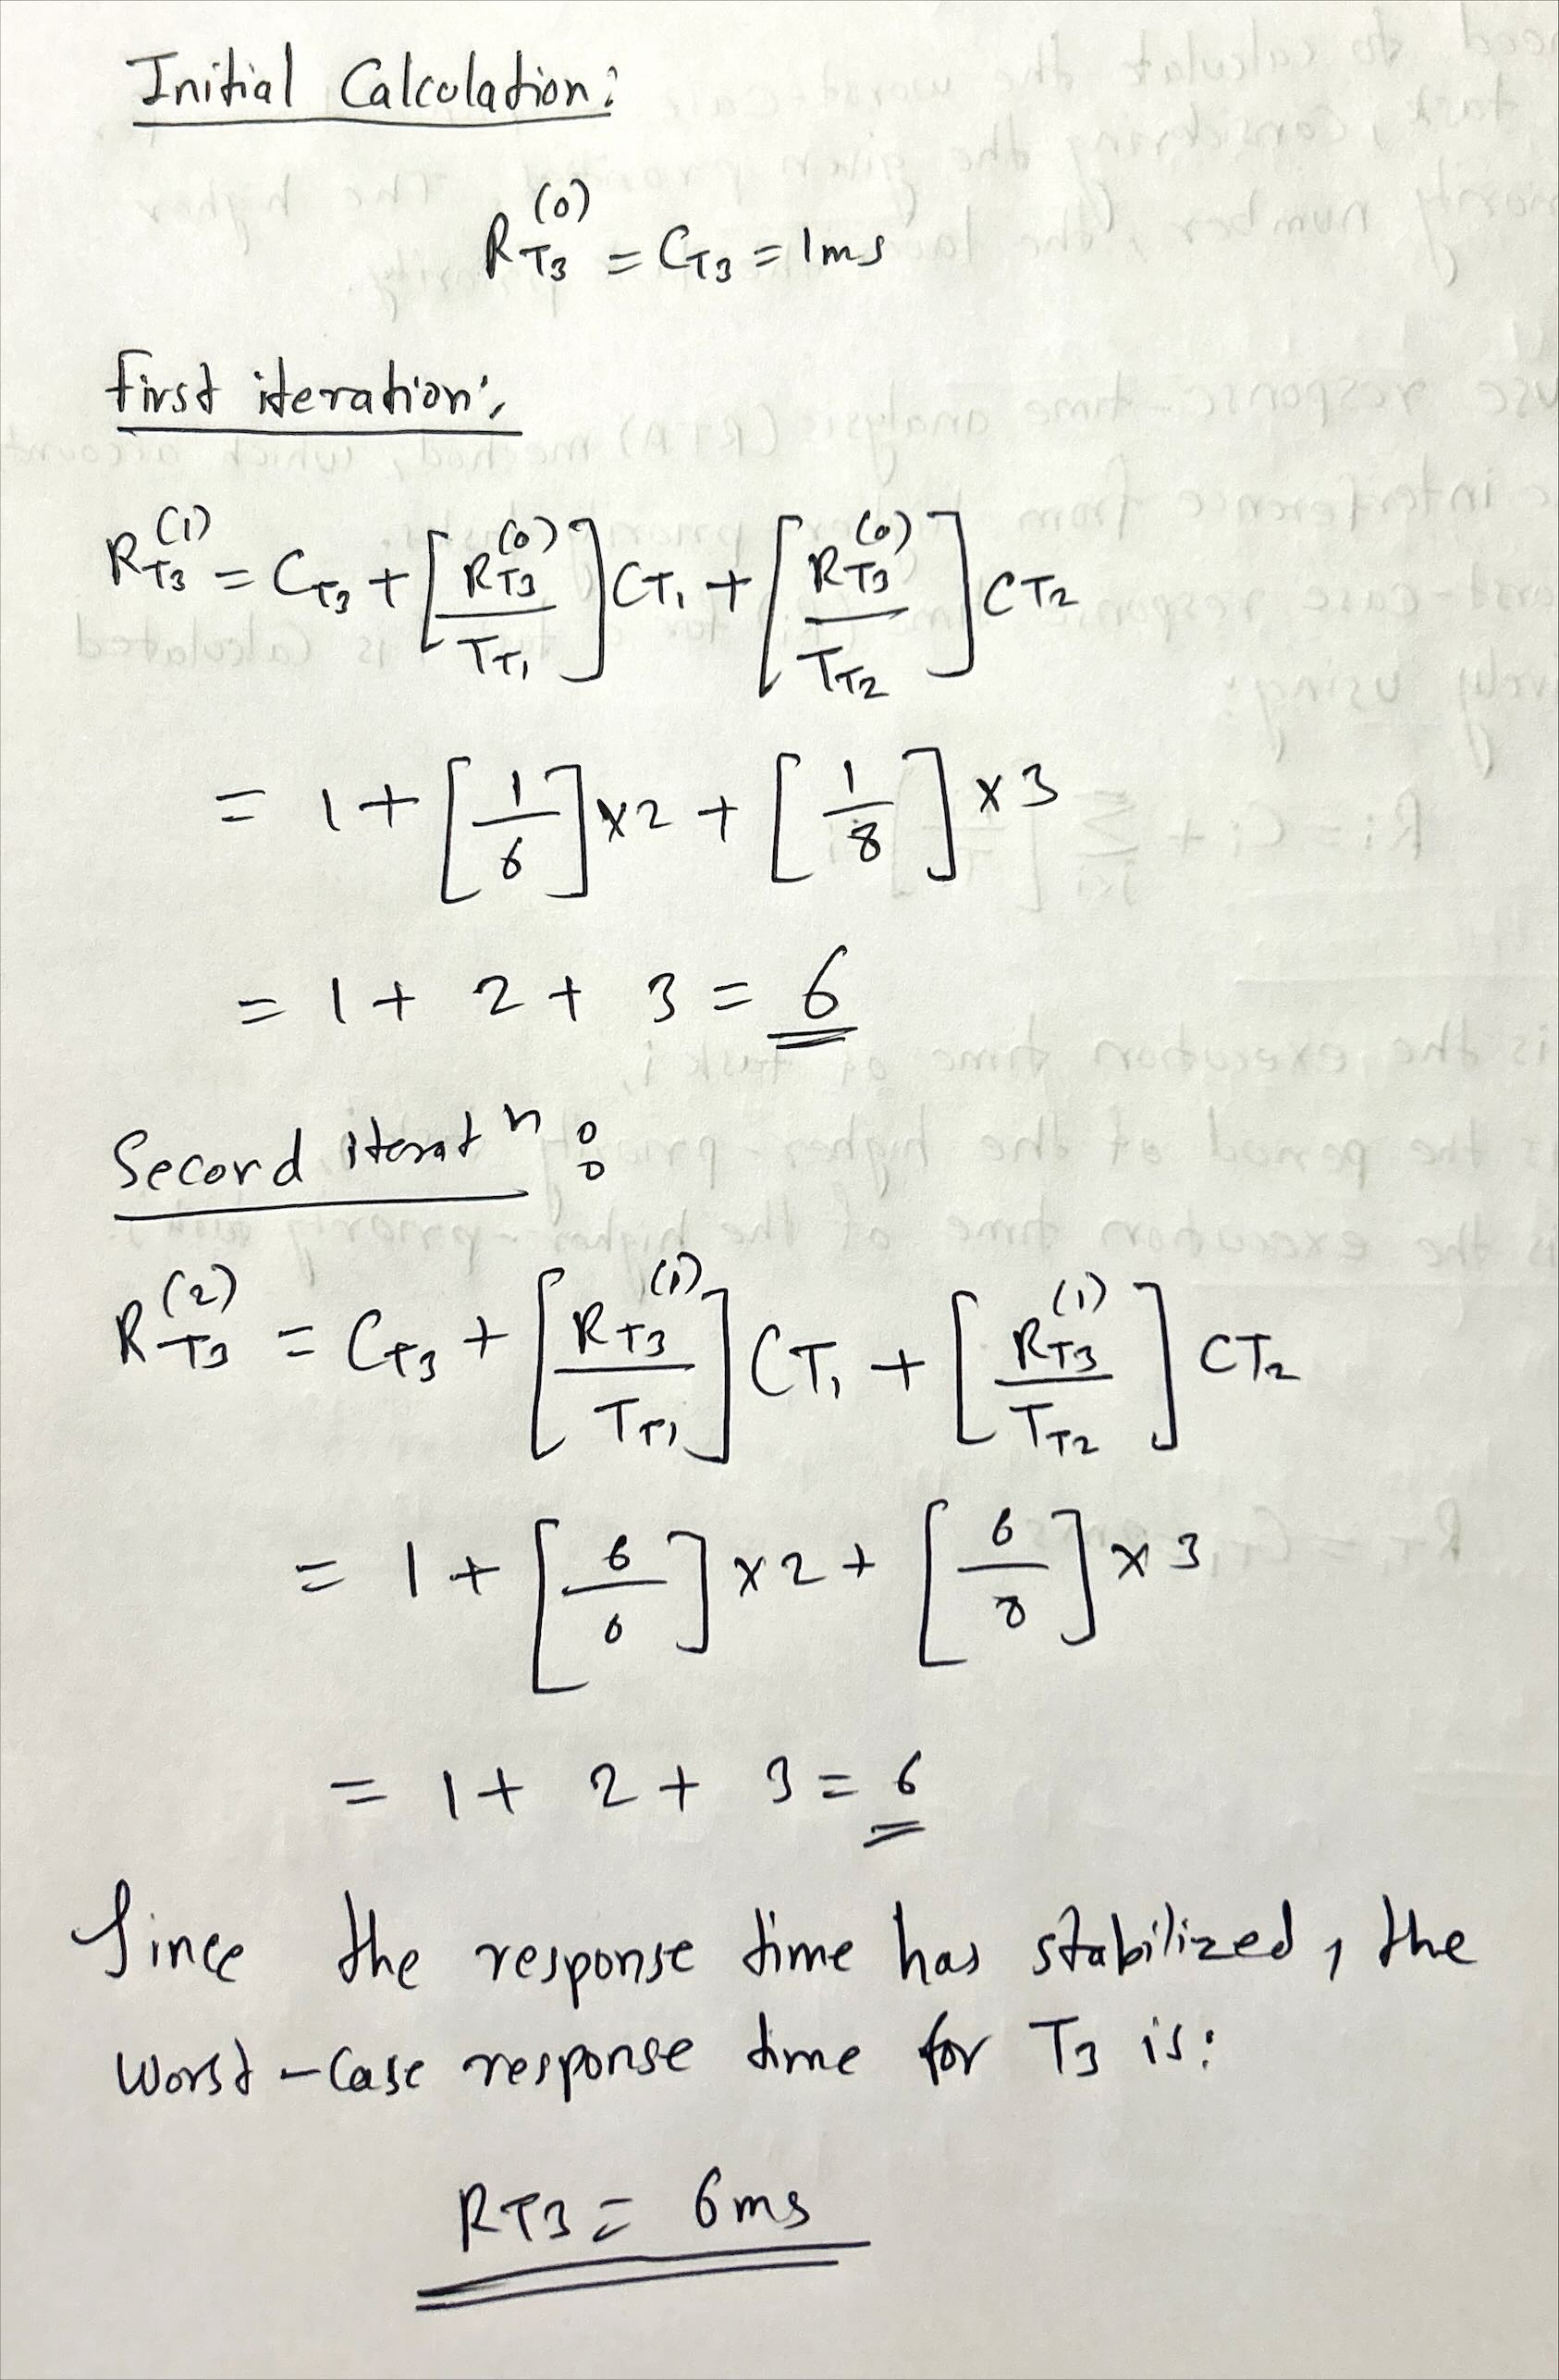

**Final Worst-Case Response Times:**

| **Task** | **Worst-Case Response Time (ms)** |
| --- | --- |
| T1 | 2 |
| T2 | 5 |
| T3 | 6 |

* **T1** completes its execution in 2 ms, which is less than its period of 6 ms.
* **T2** completes its execution in 5 ms, which is less than its period of 8 ms.
* **T3** completes its execution in 6 ms, which is less than its period of 10 ms.

Since all tasks complete within their periods, the task set is **schedulable** using the given priority scheduling.

**Question 4: Context Switching Impact**.

**Given Task Set:**

| **Task** | **Period (ms)** | **Execution Time (ms)** | **Context Switches** | **Effective Execution Time (ms)** |
| --- | --- | --- | --- | --- |
| T1 | 5 | 2 | 1 | 3 |
| T2 | 10 | 3 | 1 | 4 |
| T3 | 15 | 4 | 2 | 6 |

calculate the **effective execution time** for each task, which is the task's execution time plus the overhead caused by context switching.

For each task, the **effective execution time** is the sum of the task's **execution time** and the product of the **context switch time** and the number of **context switches**.

Given that the context switch time is **1 ms**, the formula becomes:

Effective Execution Time=Execution Time+(Context Switches×Context Switch Time)

Where the **Context Switch Time** is **1 ms**.

**Calculation:**

1. **For Task T1**:  
   * Execution Time = 2 ms
   * Context Switches = 1
   * Effective Execution Time:

Effective Execution Time = 2 + ( 1 × 1 ) = 2 + 1 = 3 ms

1. **For Task T2**:  
   * Execution Time = 3 ms
   * Context Switches = 1
   * Effective Execution Time:

Effective Execution Time = 3 + ( 1 × 1 ) = 3 + 1 = 4 ms

1. **For Task T3**:  
   * Execution Time = 4 ms
   * Context Switches = 2
   * Effective Execution Time:

Effective Execution Time = 4 + ( 2 × 1 ) = 4 + 2 = 6 ms

* The **effective execution time** for each task is the sum of the actual execution time and the overhead caused by context switching.
* **T1** has an effective execution time of **3 ms**, **T2** has **4 ms**, and **T3** has **6 ms**, considering the 1 ms context switch overhead for each context switch.

**Question 5: Missed Deadlines in a Hyperperiod**.

**Given Task Set:**

| **Task** | **Period (ms)** | **Execution Time (ms)** | **Number of Deadlines in Hyperperiod (30 ms)** | **Deadlines Missed** |
| --- | --- | --- | --- | --- |
| T1 | 6 | 2 | ? | ? |
| T2 | 10 | 3 | ? | ? |
| T3 | 12 | 4 | ? | ? |

We need to calculate the **number of deadlines missed** for each task in a hyperperiod of **30 ms**.

**Step 1: Number of Deadlines in the Hyperperiod:**

The **number of deadlines** for each task within the **30 ms hyperperiod** can be calculated by dividing the hyperperiod by the task's period.

Number of Deadlines=Hyperperiod/Task Period

1. **For Task T1**:
   * Period = 6 ms
   * Hyperperiod = 30 ms

Number of Deadlines for T1 = 30 / 6 = 5

1. **For Task T2**:
   * Period = 10 ms
   * Hyperperiod = 30 ms

Number of Deadlines for T2 = 30 / 10 = 3

1. **For Task T3**:
   * Period = 12 ms
   * Hyperperiod = 30 ms

Number of Deadlines for T3 = 30 / 12 = 2.5 ⇒ 2  deadlines

**Step 2: Check for Missed Deadlines:**

We will check whether any deadlines are missed by considering whether the task can finish execution before its next deadline, assuming no preemption for this calculation.

1. **For Task T1**:  
   * Execution Time = 2 ms
   * Since T1 has a period of 6 ms and an execution time of 2 ms, it will easily meet each of its 5 deadlines in the 30 ms hyperperiod.
   * **Deadlines Missed = 0**
2. **For Task T2**:  
   * Execution Time = 3 ms
   * T2 has a period of 10 ms and an execution time of 3 ms. It will also meet all 3 of its deadlines within its periods without missing any deadlines.
   * **Deadlines Missed = 0**
3. **For Task T3**:  
   * Execution Time = 4 ms
   * T3 has a period of 12 ms and an execution time of 4 ms. Since it completes execution before each deadline within its period, it will meet both of its deadlines within the 30 ms hyperperiod.
   * **Deadlines Missed = 0**

**Final Table:**

| **Task** | **Period (ms)** | **Execution Time (ms)** | **Number of Deadlines in Hyperperiod (30 ms)** | **Deadlines Missed** |
| --- | --- | --- | --- | --- |
| T1 | 6 | 2 | 5 | 0 |
| T2 | 10 | 3 | 3 | 0 |
| T3 | 12 | 4 | 2 | 0 |

* **No deadlines are missed** for any of the tasks in the 30 ms hyperperiod.
* All tasks complete their execution within their periods, ensuring they meet their deadlines.

**PART B**

**Question 1** and set up the tasks in **Cheddar** step by step for both **non-preemptive** and **preemptive priority-driven scheduling**.

**Task Graph**:

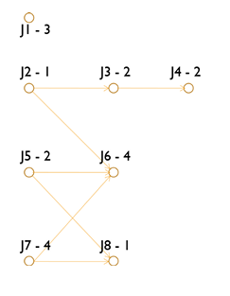

The task graph includes 8 tasks (**J1 to J8**) with the following characteristics:

* All tasks have a **deadline of 12 ms**.
* All tasks except **J5** release at time **0 ms**, while **J5** releases at **4 ms**.
* Task priorities: **J1** has the highest priority, followed by **J2, J3, ..., J8**.